1. Create a Client application running on LocalHost that connects at startup on port 55000 to the Server on port 55000
2. The client should be able to receive from the server the following data frame of 512 bytes:

* MSG_ID, SEQ_CNT and CRC32 are uint32 types
* PAYLOAD is an array of uint8[500];

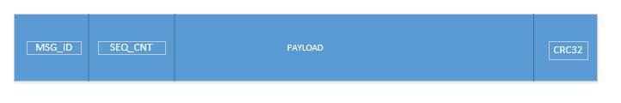

1. The client should be able to store a “synchronized package” of 3 frames (IDs: 1, 2 and 3) based on the SEQ_CNT

A Synchronized package consist of 3 frames that have incrementing IDs ( 1, 2, 3) and the same SEQ_CNT (eg: 0, 1, 2...)

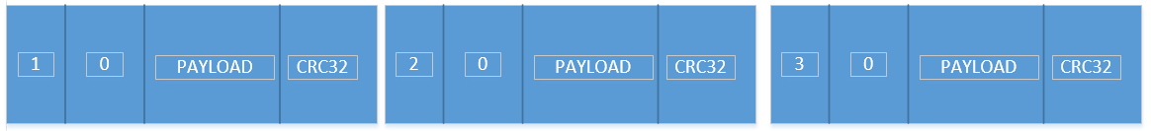

1. The client should be able to store the last 3 synchronized packages, in a circular buffer. The highest SEQ_CNT has the highest priority

* Use the provided Server application, that listens on Port 55000 for any incoming connection. The server will send the data frame with incremental SEQ_CNT for each transmission at on “key press” events as follows:
  + “1” -> data frame with MSG_ID = 1
  + “2” -> data frame with MSG_ID = 2
  + “3” -> data frame with MSG_ID = 3

Eg: On the first key entered as “1” it will send a package with MSG_ID=1 and SEQ_CNT=0

On the second key entered as “1” it will send a package with MSG_ID=1 and SEQ_CNT=1

Etc..

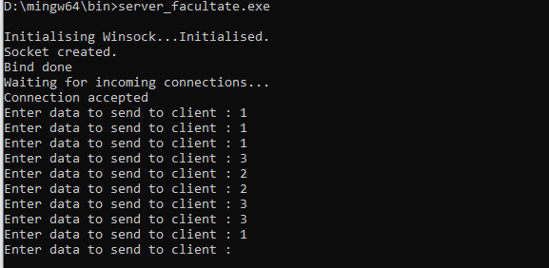

Package sent for the input given above:

- MSG_ID=1, SEQ_CNT=0, Payload[500], CRC

- MSG_ID=1, SEQ_CNT=1, Payload[500], CRC

- MSG_ID=1, SEQ_CNT=2, Payload[500], CRC First synchronized package

- MSG_ID=3, SEQ_CNT=0, Payload[500], CRC

- MSG_ID=2, SEQ_CNT=0, Payload[500], CRC

- MSG_ID=2, SEQ_CNT=1, Payload[500], CRC Second synchronized package

- MSG_ID=3, SEQ_CNT=1, Payload[500], CRC

- MSG_ID=3, SEQ_CNT=2, Payload[500], CRC

- MSG_ID=1, SEQ_CNT=4, Payload[500], CRC

Evaluation:

1. 1p
2. 2p
3. 2p
4. 1p